Default GUI

OpenCamera GUI is controlled by GUI class. This is abstract class and each gui developer have to implement their own GUI which have to place their layout on main layout of application (R.layout.mainLayout1). Appropriate GUI created in MainScreen file in OnCreate method. Default GUI is AlmalenceGUI class which uses gui_almalence_layout.xml file.

Structure of Default GUI in gui_almalence_layout.xml

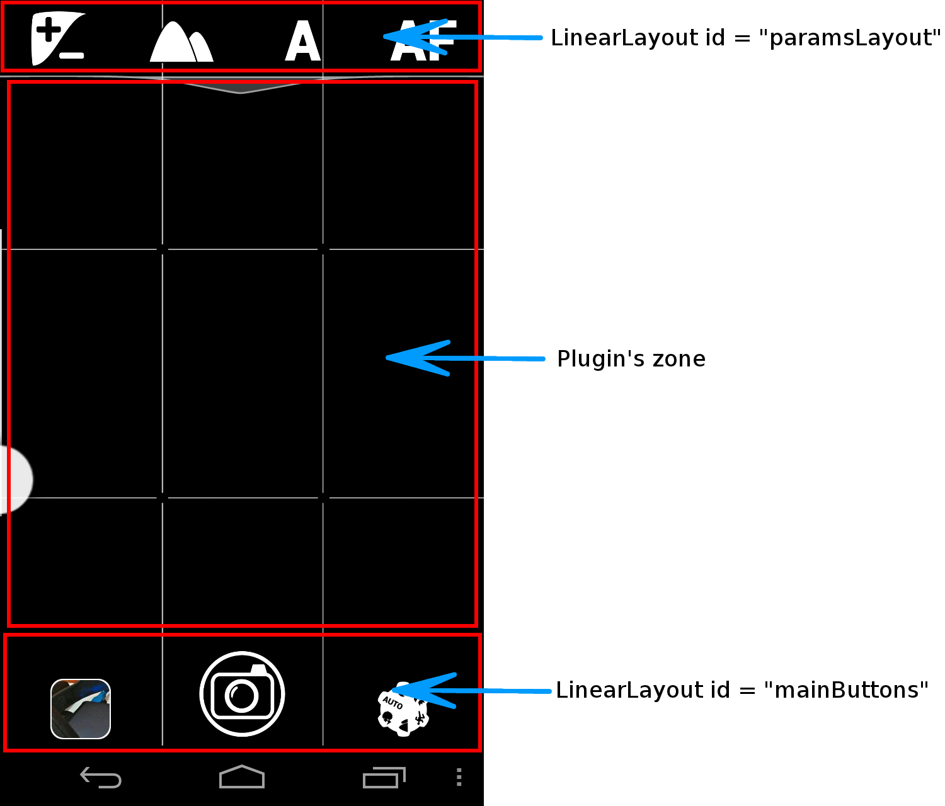

1) Plugin's zone – place for plugin’s views. Each plugin may have 2 types of views – ordinary views and info views.

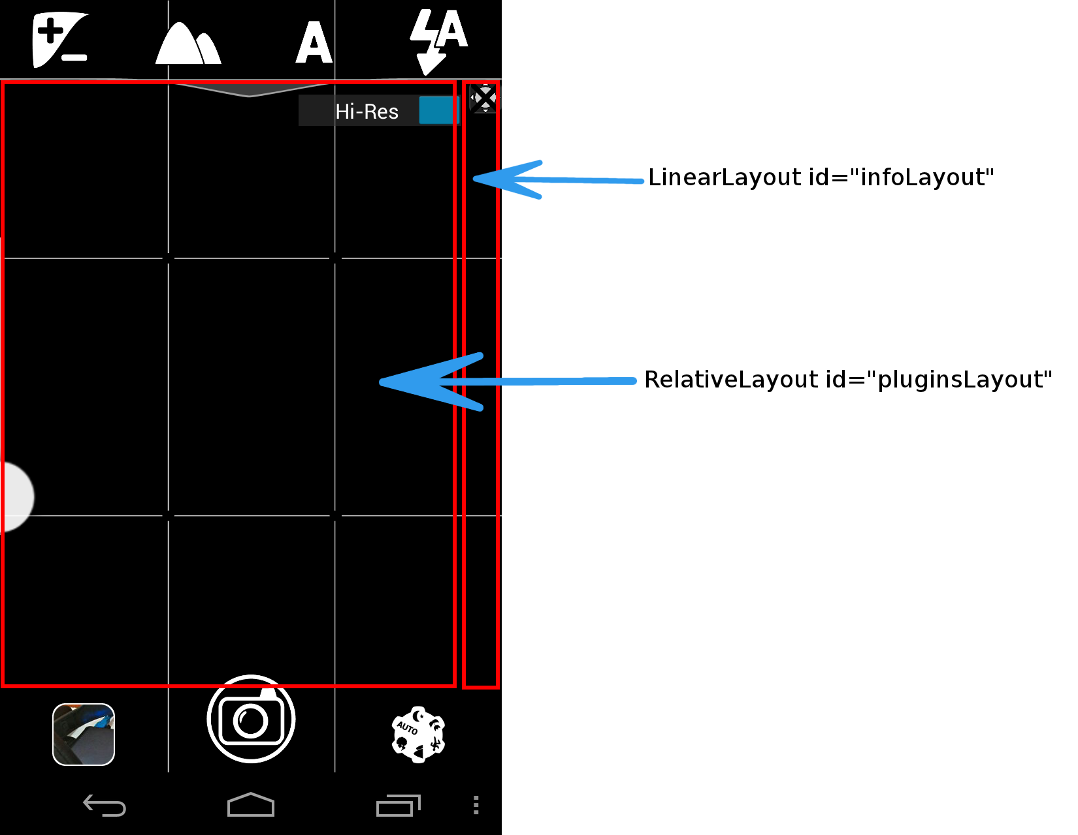
Also gui_almalence_layout.xml has two additional plugin's layout:
- Full screen layout for such plugins as viewfinder grids (RelativeLayout id=”fullscreenLayout”)
- Full screen layout for special plugins. (RelativeLayout id=”specialPluginsLayout”)

2) Top menu layout (LinearLayout id=”paramsLayout”) – top menu, consists of camera parameters buttons, plugin's top menu buttons: Exposure correction, Scene mode, White balance, Focus mode, Flash mode, ISO, Front/Rear camera.

<LinearLayout
android:id="@+id/paramsLayout"
…>
<com.almalence.googsharing.RotateImageView android:id="@+id/evButton"
…/>
<com.almalence.googsharing.RotateImageView android:id="@+id/sceneButton"
…/>
<com.almalence.googsharing.RotateImageView android:id="@+id/wbButton"
…/>
<com.almalence.googsharing.RotateImageView android:id="@+id/focusButton"
…>
<com.almalence.googsharing.RotateImageView android:id="@+id/flashButton"
…/>
<com.almalence.googsharing.RotateImageView android:id="@+id/isoButton"
…/>
<com.almalence.googsharing.RotateImageView android:id="@+id/camerachangeButton"
…/>
</LinearLayout>

On the screen simultaneously can be only 4 buttons. Which of them depends on GUI logic.
Each top menu buttons calls their own extended menu with supported values. For example menu of White Balance on Google Nexus4:

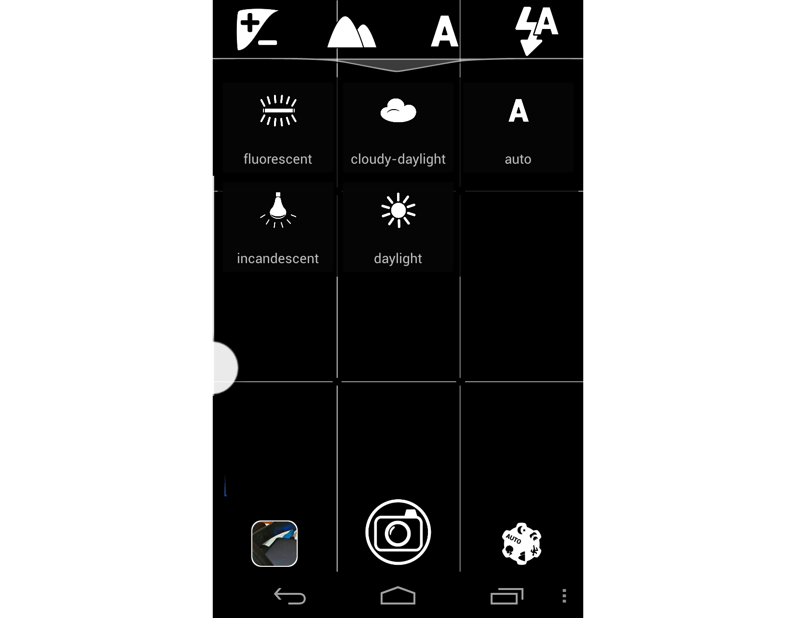

3) Main buttons layout (LinearLayout id=”mainButtons”) – bottom menu, contains 3 buttons: Gallery, Shutter and Mode.

<LinearLayout
android:id="@+id/mainButtons"
…>
<com.almalence.opencam.ui.RotateImageView
android:id="@+id/buttonGallery"
…>
</com.almalence.opencam.ui.RotateImageView>

<com.almalence.opencam.ui.RotateImageView
android:id="@+id/buttonShutter"
…>
</com.almalence.opencam.ui.RotateImageView>

<com.almalence.opencam.ui.RotateImageView
android:id="@+id/buttonSelectMode"
…>
</com.almalence.opencam.ui.RotateImageView>
</LinearLayout>

On Select mode button click appears menu (LinearLayout id=”modeLayout”) where user may choose OpenCamera mode (set of active plugins).

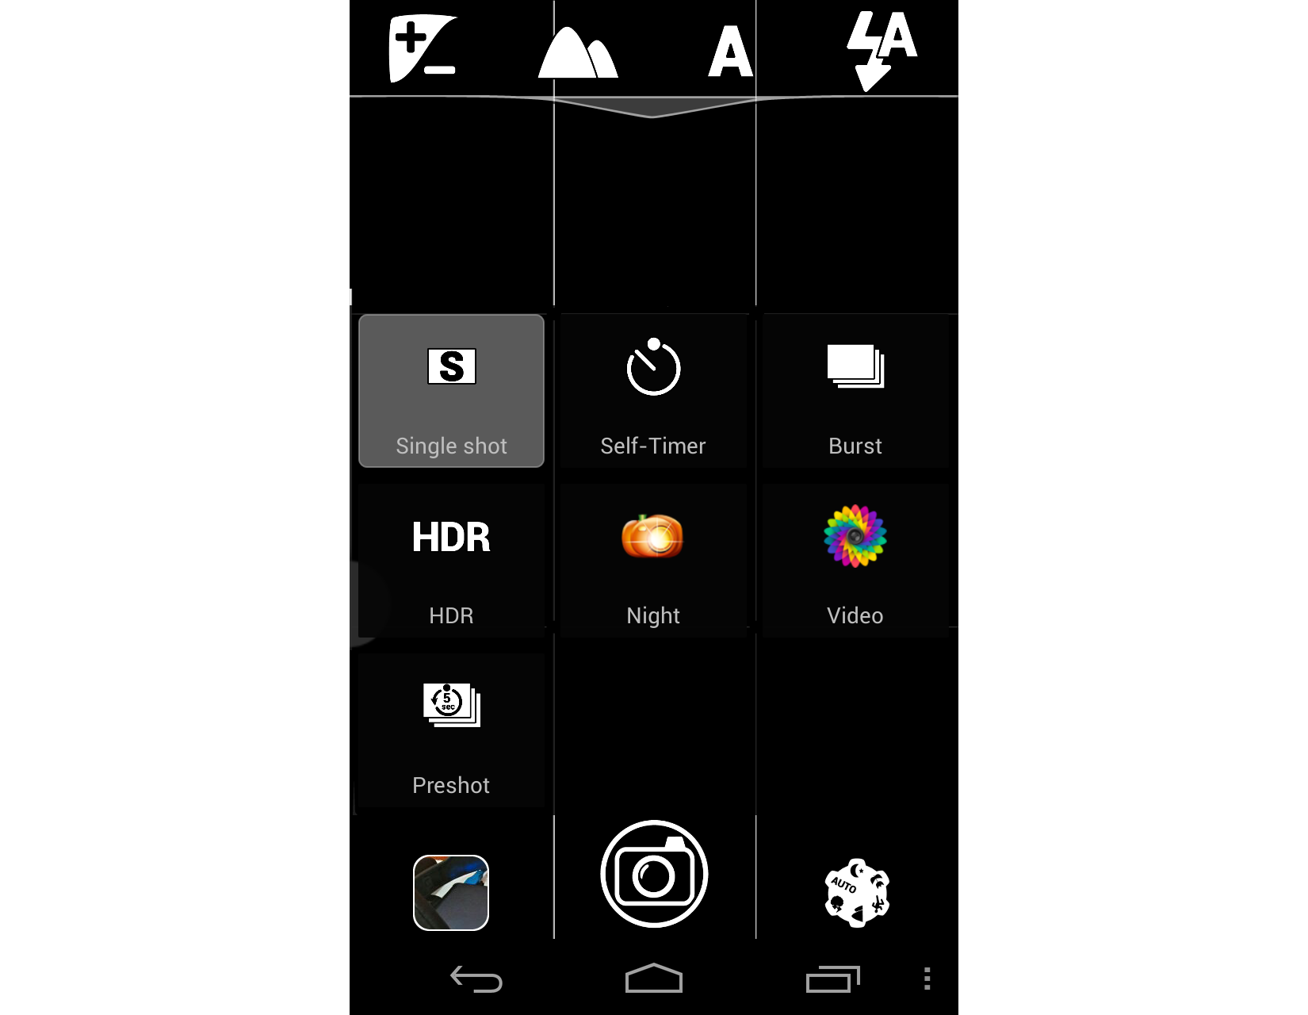

Important Note: Set of camera parameter buttons and theirs value’s buttons depends on camera model. This feature is controlling by GUI object.

AlmalenceGUI object

AlmalenceGUI is a singleton java class object extends abstract GUI class (com/almalence/opencam/ui/AlmalenceGUI.java). It manages top menu buttons and plugin’s views. May call it GUI Manager to better understand its role.

Managing of top menu buttons
In method onCreate() GUI Manager gets standard top menu buttons such as camera parameters from gui_almalence_layout.xml and save it in appropriate lists (actually in Map objects). Also there is created top menu buttons of all plugins and created and initialized all camera parameters value buttons.

// Create standard OpenCamera's buttons and theirs OnClickListener
@Override
public void onCreate()
{
//Get all top menu buttons
topMenuButtons.put(MODE_EV, guiView.findViewById(R.id.evButton));
topMenuButtons.put(MODE_SCENE, guiView.findViewById(R.id.sceneButton));
topMenuButtons.put(MODE_WB, guiView.findViewById(R.id.wbButton));
...

//Create and initialize camera parameters buttons
SceneModeButtons = initCameraParameterModeButtons(icons_scene, SceneModeButtons, MODE_SCENE);
WBModeButtons = initCameraParameterModeButtons(icons_wb, WBModeButtons, MODE_WB);
...

//Create top menu buttons for plugins
createPluginTopMenuButtons();

...
}

Then in method onCameraCreate() GUI Manager remove all top menu buttons buttons from paramsLayout, checks what camera parameter is available for managing at current device and place on paramsLayout only such buttons. This menu is configurable by long click on any button on it. So on start of program there may be not only camera parameters buttons but any top menu buttons configured by user. All of this logic implemented in onCameraCreate() method. If camera parameter supported in this method also created all appropriate parameter values and they added to appropriate layout.

@Override
public void onCameraCreate() {
...
// Remove buttons from previous camera start
removeAllViews(topMenuButtons);
removeAllViews(topMenuPluginButtons);
...
//Create Scene mode button and adding supported scene modes
List<String> supported_scene = MainScreen.thiz.getSupportedSceneModes();
if(supported_scene != null && supported_scene.size() > 0)
{
mSceneModeSupported = true;
//Gets id of scene mode button
defaultQuickControl2 = String.valueOf(MODE_SCENE);

String initValue = preferences.getString(sSceneModePref, sDefaultValue);
if(!supported_scene.contains(initValue))
{
if(MainScreen.thiz.isFrontCamera())
initValue = supported_scene.get(0);
else
initValue = sDefaultValue;
}

Set<String> keys = SceneModeButtons.keySet();
Iterator<String> it = keys.iterator();
while(it.hasNext())
{
String scene_name = it.next();
if(supported_scene.contains(scene_name))
{
activeScene.add(SceneModeButtons.get(scene_name));
activeSceneNames.add(scene_name);
}
}

scenemodeAdapter.Elements = activeScene;
GridView gridview = (GridView)guiView.findViewById(R.id.scenemodeGrid);
gridview.setAdapter(scenemodeAdapter);
}
else
{
mSceneModeSupported = false;
mSceneMode=null;
}
...
}

Customization of top menu panel

User may customize top menu with any camera parameters buttons and plugin's top menu buttons. The action started when use make a long click on any button on top menu panel. Then user will see a such of menu
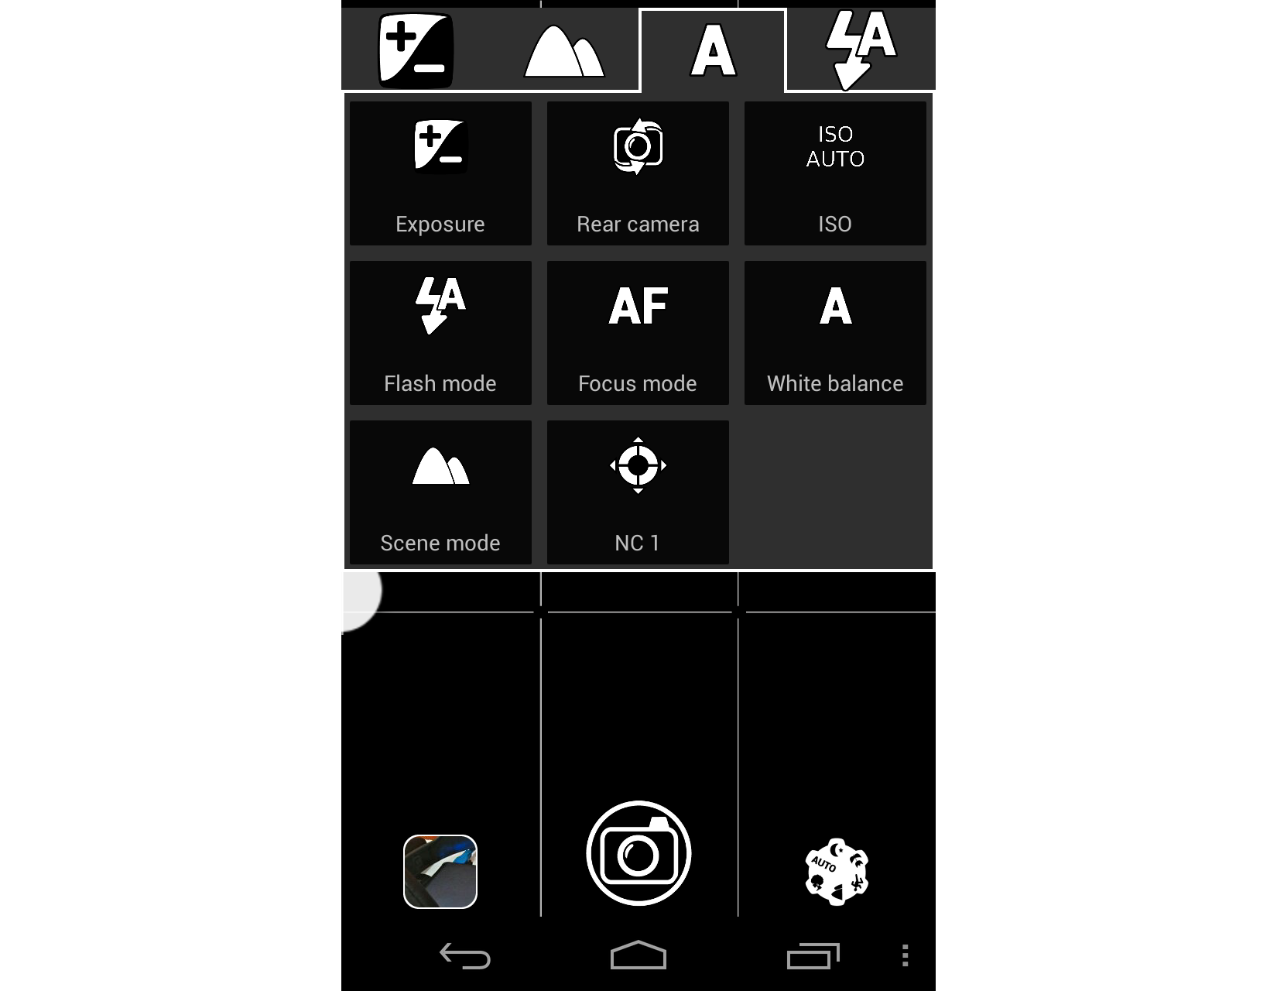

Managing of plugin’s views

GUIManager has a several lists for store plugin’s views

//Lists of added plugin's controls
List<View> VFViews;
List<View> FullScreenVFViews;
List<View> CaptureViews;
List<View> ProcessingViews;
List<View> FilterViews;
List<View> ExportViews;

Plugins adds and removes theirs views by calling methods addView() and removeView()

//Public interface for all plugins
//Automatically decide where to put view and correct view's size if necessary
public void addView(View view, PluginType pluginType)
{
switch(pluginType)
{
case ViewFinder:
{
VFViews.add(view);
} break;

case Capture:
{
CaptureViews.add(view);
} break;
. . .
}
}

public void removeView(View view, PluginType pluginType)
{
switch(pluginType)
{
case ViewFinder:
{
VFViews.remove(view);
} break;
. . .
}
}

After layouts are created by Android, GUIManager can add views on them. It happens in onGUICreate()

//onGUICreate called when main layout is rendered and size's variables is available
public void onGUICreate()
{
//Add plugin's views to the screen
for(int i=0; i<VFViews.size();i++)
{
this.addVFPluginView(VFViews.get(i));
}

for(int i=0; i<FullScreenVFViews.size();i++)
this.addFullScreenVFPluginView(FullScreenVFViews.get(i));

//Always check whether view is suitable to remaining space
for(int i=0; i<CaptureViews.size();i++)
{
if(CaptureViews.get(i).getLayoutParams().height > this.getMaxLeftViewHeight())
viewHeight = this.getMaxLeftViewHeight();
else
viewHeight = CaptureViews.get(i).getLayoutParams().height;

if(CaptureRemainingHeight >= viewHeight)
{
CaptureRemainingHeight -= viewHeight;
this.addCapturePluginView(CaptureViews.get(i));
}
}
. . .
}

In method onStop() GUIManager removes all plugin’s view from layouts

public void onStop()
{
//Remove plugin's views from the screen
for(int i=0; i<VFViews.size();i++)
this.removeVFPluginView(VFViews.get(i));

for(int i=0; i<FullScreenVFViews.size();i++)
this.removeFullScreenVFPluginView(FullScreenVFViews.get(i));

for(int i=0; i<CaptureViews.size();i++)
this.removeCapturePluginView(CaptureViews.get(i));

for(int i=0; i<ProcessingViews.size();i++)
this.removeProcessingPluginView(ProcessingViews.get(i));

for(int i=0; i<FilterViews.size();i++)
this.removeFilterPluginView(FilterViews.get(i));

for(int i=0; i<ExportViews.size();i++)
this.removeExportPluginView(ExportViews.get(i));

for(int i=0; i<ModeViews.size();i++)
this.removeModeView(ModeViews.get(i));
}

For every plugin’s view GUIManager checks whether space on layout is enough to add this view on it. And this space availability is set in few methods:

//Supplementary methods for getting appropriate sizes for plugin's views
public int getLeftLayoutHeight()
{
return ((RelativeLayout)MainScreen.thiz.findViewById(R.id.pluginsLayout)).getHeight()/3;
}

public int getMaxLeftViewHeight()
{
return ((RelativeLayout)MainScreen.thiz.findViewById(R.id.pluginsLayout)).getHeight()/9;
}

public int getRightLayoutHeight()
{
return (int) ((int)((RelativeLayout)MainScreen.thiz.findViewById(R.id.pluginsLayout)).getHeight()*0.3);
}

public int getMaxRightViewHeight()
{
return (int)((((RelativeLayout)MainScreen.thiz.findViewById(R.id.pluginsLayout)).getHeight()*0.3)/3);
}

public int getMaxViewWidth()
{
return ((RelativeLayout)MainScreen.thiz.findViewById(R.id.pluginsLayout)).getWidth()/2;
}

Such constant numbers means next: for ‘left’ views size is limited to screenSize/9, each plugin’s layout may contain only 3 views (findViewById(R.id.pluginsLayout)).getHeight()/3), right Export plugin layout fills only 30% space, other 70% space is for Viewfinder`s views.
This logic is not clear and not good and may be changed in the future.

Custom GUI

Customization of camera parameters buttons and bottom menu buttons

What you may modify?
- Layout’s place
- Layout’s parameters
- Button’s style
- Type of button

Suppose you want to move camera parameters layout from top to left, add additional menu button and change button’s style

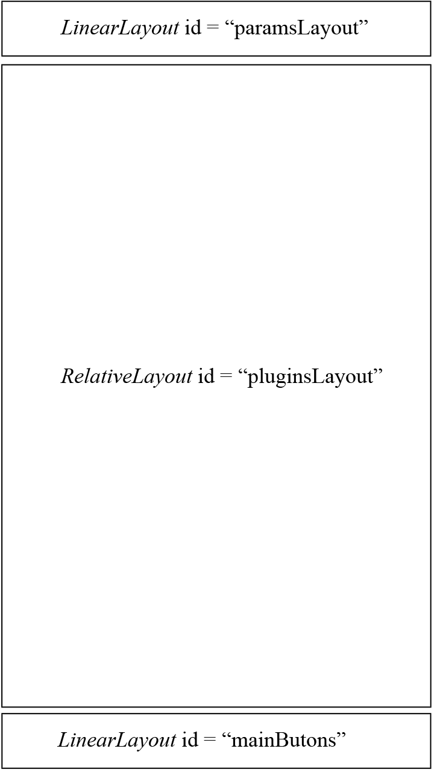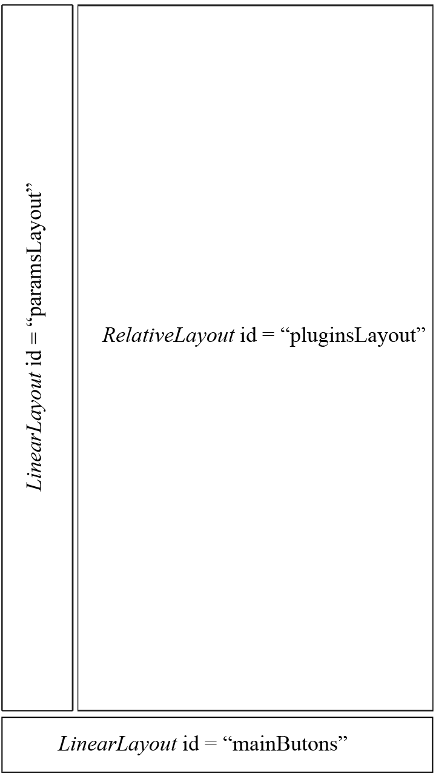

Steps to achieve this:

- To change place you have to modify only few layout parameters. As the main layout is RelativeLayout all child layouts lays relatively to each other. And to move camera parameters layout to left you have to make such changes in main.xml:

<RelativeLayout
android:id="@+id/pluginsLayout"
android:layout_width="fill_parent"
android:layout_height="fill_parent"
android:layout_above="@+id/mainButtons"
android:layout_below="@+id/paramsLayout" - remove this parameter
android:layout_right="@+id/paramsLayout" – add this parameter
. . . />
. . .
<LinearLayout
android:id="@+id/paramsLayout"
android:orientation="vertical" - change this parameter from ‘horizontal’ to ‘vertical’
android:layout_width="fill_parent"
android:layout_height="wrap_content"
android:layout_gravity="left" - change this parameter from ‘top’ to ‘left’
android:layout_alignParentTop="true">

In appropriate manner you’ll have to modify layouts for camera parameters values.

- Add new button to menu is simple.
Just add Button item (or ImageButton) to main.xml, point onClick method and realize button’s click behavior in GUIManager.

<LinearLayout
android:id="@+id/paramsLayout"
…>
<Button android:id="@+id/newCoolButton"
…
android:onClick="onButtonClick"/> - point to onButtonClick method
…

In GUIManager modify onButtonClick method. Just add new case statement:

public void onButtonClick(View button)
{
int id = button.getId();
switch(id)
{
…
case R.id.newCoolButton: //add new case statement
{
//Add button click behavior here
}break;
…
}

- You absolutely free to change menu’s buttons style. You may do this in main.xml as well in onCreate() method of GUIManager.

Customization of plugin’s layout
In the same manner as for Camera Parameters layout, you may change layouts for plugin’s view. Plugin’s layout is a RelativeLayout that has LinearLayouts and one RelativeLayout as a child. Places for layout are controlled by the same layout’s parameters as for main layout.
<RelativeLayout
android:id="@+id/pluginsLayout"
android:layout_width="fill_parent"
android:layout_height="fill_parent"
android:layout_above="@+id/mainButtons"
android:layout_below="@+id/paramsLayout"
android:layout_marginLeft="1dip"
android:layout_marginRight="1dip">
<LinearLayout
android:id="@+id/capturePluginLayout"
android:orientation="vertical"
android:layout_width="wrap_content"
android:layout_height="wrap_content"
android:layout_alignParentLeft="true"
android:layout_alignParentTop="true"
android:layout_above="@+id/processingPluginLayout">
</LinearLayout>
<LinearLayout
android:id="@+id/processingPluginLayout"
android:orientation="vertical"
android:layout_width="wrap_content"
android:layout_height="wrap_content"
android:layout_alignParentLeft="true"
android:layout_centerVertical="true"
android:layout_above="@+id/filterPluginLayout">
</LinearLayout>
<LinearLayout
android:id="@+id/filterPluginLayout"
android:orientation="vertical"
android:layout_width="wrap_content"
android:layout_height="wrap_content"
android:layout_alignParentLeft="true"
android:layout_alignParentBottom="true">
</LinearLayout>
<LinearLayout
android:id="@+id/exportPluginLayout"
android:orientation="vertical"
android:layout_width="wrap_content"
android:layout_height="wrap_content"
android:layout_alignParentRight="true"
ndroid:layout_alignParentTop="true"
ndroid:layout_above="@+id/viewfinderPluginLayout">
</LinearLayout>
<RelativeLayout
android:id="@+id/viewfinderPluginLayout"
android:orientation="vertical"
android:layout_width="wrap_content"
android:layout_height="wrap_content"
android:layout_alignParentRight="true"
android:layout_alignParentBottom="true">
</RelativeLayout>
</RelativeLayout>
To control maximum sizes of plugin’s view and plugin’s layouts use methods

//Supplementary methods for getting appropriate sizes for plugin's views
public int getLeftLayoutHeight()
{
return ((RelativeLayout)MainScreen.thiz.findViewById(R.id.pluginsLayout)).getHeight()/3;
}

public int getMaxLeftViewHeight()
{
return ((RelativeLayout)MainScreen.thiz.findViewById(R.id.pluginsLayout)).getHeight()/9;
}

public int getRightLayoutHeight()
{
return (int) ((int)((RelativeLayout)MainScreen.thiz.findViewById(R.id.pluginsLayout)).getHeight()*0.3);
}

public int getMaxRightViewHeight()
{
return (int)((((RelativeLayout)MainScreen.thiz.findViewById(R.id.pluginsLayout)).getHeight()*0.3)/3);
}

public int getMaxViewWidth()
{
return ((RelativeLayout)MainScreen.thiz.findViewById(R.id.pluginsLayout)).getWidth()/2;
}

Modify constant values (3, 9, 0.3, 2, etc.) to achieve desired ratio.

How plugin may add a View?

Every plugin may override some parent’s methods to add their own views on plugin’s layout.
First of all it must create a view and implement onClickListener for it. Suppose we want to create a Button. We may create it in Plugin’s constructor or in onCreateMain() method:

public class TestTimerCapturePlugin extends Plugin {

private Button selfTimerButton;

public void onCreateMain()
{
selfTimerButton = new Button(MainScreen.mainContext);

selfTimerButton.setTextColor(Color.WHITE);
selfTimerButton.setBackgroundResource(R.drawable.thumbnail_background);

selfTimerButton.setOnClickListener(new View.OnClickListener() {
public void onClick(View v)
{
//Some plugin behavior
});
}
. . .
}

You may use supplementary methods of GUIManager to get maximum sizes for plugin’s views. It’s possible only in method onGUICreate()
public void onGUICreate()
{
android.widget.LinearLayout.LayoutParams lp = new android.widget.LinearLayout.LayoutParams(
GUIManager.getInstance().getMaxViewWidth()/3,
GUIManager.getInstance().getMaxLeftViewHeight());
lp.setMargins(0, 2, 0, 0);
selfTimerButton.setLayoutParams(lp);
}

Then implement 2 methods for adding and removing view from GUI. It’s necessary to point right plugin type in second parameter of these methods.

public void onStartMain()
{
GUIManager.getInstance().addView(selfTimerButton, PluginType.Capture);
}

public void onStopMain()
{
GUIManager.getInstance().removeView(selfTimerButton, PluginType.Capture);
}

Note: management of plugin’s views sizes and plugin’s layouts ratio may be modified in future releases.

